PHASE 3: PROJECT DESIGN PHASE

3.1 System Design
The proposed system follows this process:
Student/Teacher → Create Ticket → Flow Trigger → Keyword Analysis → Category/Subcategory Assignment → Email Notification
3.2 Classification Design
The flow checks the short description and identifies the corresponding issue.

Wi-Fi
Condition:
Short Description contains:
Wi Fi OR Network
Result:
Category = Network
Subcategory = Wi-Fi

Projector
Condition:
Short Description contains:
Projector
Result:
Category = Hardware
Subcategory = Projector

Password
Condition:
Short Description contains:
Password OR Login
Result:
Category = Access
Subcategory = Forgot Password

Slow Compter
Condition:
Short Description contains:
Slow OR Hanging
Result:
Category = Performance
Subcategory = Slow Computer

3.3 Category–Subcategory Dependency
The Subcategory field is designed as a dependent choice field.
Category | Available Subcategory
Network | Wi-Fi
Hardware | Projector
Access | Forgot Password
Performance | Slow Computer
This prevents unrelated subcategories from being selected.

3.4 Flow Design
The flow contains:
Trigger
↓
Record Created
↓
Check Category is Empty
↓
If WiFi/Network
↓
Update Category + Subcategory
↓
Else If Projector
↓
Update Category + Subcategory
↓
Else If Password/Login
↓
Update Category + Subcategory
↓
Else If Slow/Hanging
↓
Update Category + Subcategory
↓
Send Email

3.5 Design Architecture

User
│
▼
Create IT Ticket
│
▼
Record Created
│
▼
Flow Designer
│
┌───────┼────────┐
▼ ▼ ▼
WiFi Projector Password
│ │ │
▼ ▼ ▼
Network Hardware Access
│ │ │
└───────┼────────┘
▼
Slow / Hanging
│
▼
Performance
│
▼
Email Notification

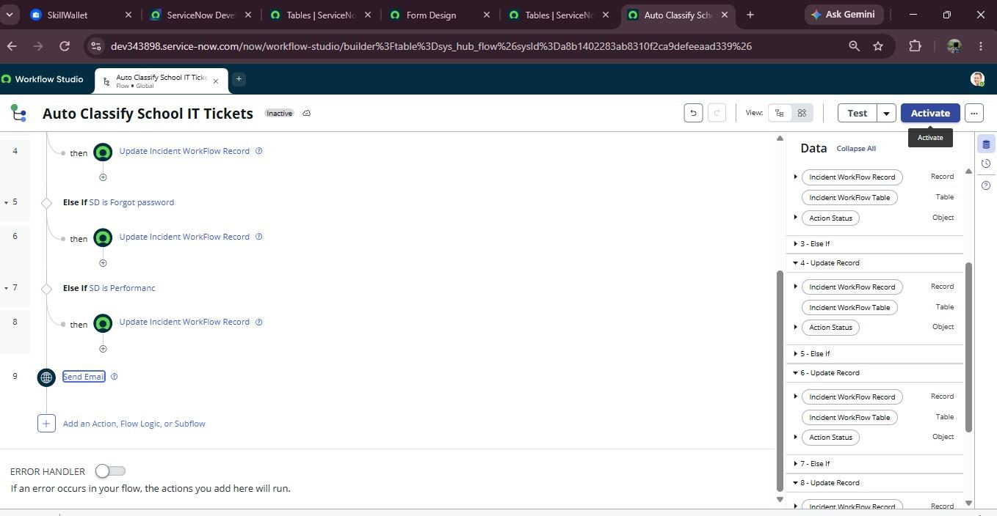
Fig; Designed automation flow for automatic ticket classification.

